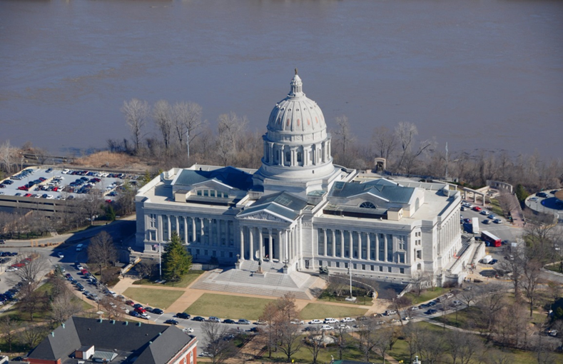
LeadingAge Missouri
2023 Public Policy Advocacy Day
Jefferson City, Missouri
Leading Change
Advocacy, Education, Networking
Tuesday, March 21, 2023
3:00 - 5:30 PM LeadingAge Missouri Board Meeting

Wednesday, March 22, 2023
9:00 - 10:00 AM Registration
10:00 -12:00 AM Education (QIPMO)- Knowledge is Power: Strategies to Avoid the Top Citations in Missouri( 2 CEU’s)
12:15 – 1:30 PM Lunch with Speaker (No CEU’s)
1:30 - 4:30 PM Capitol Visits (Transportation Provided to and from Capitol)

2023 Public Policy Advocacy Day LeadingAge Missouri
________________________________________________________________________________

LeadingAge Board Meeting
3pm-5:30pm

SCHEDULE
Tuesday, March 21
Missouri Baptist Convention
400 E High Street
Jefferson City, MO 65101

Review Issues
Receive this year’s Key Issues to discuss and learn about the current state of the legislative process on key issues in the Capitol.

Registration
9:00 a.m. - 10:00 a.m.

QIPMO Education (2 CEUs)
10:00 a.m. - 12:00 p.m.

Lunch (included) with Speaker
12:15 p.m. - 1:30 p.m.

Afternoon Legislator Visits at the Capitol
1:30 p.m. – 4:00 p.m.

SCHEDULE
Wednesday, March 22
The Millbottom
400 W Main Street
Jefferson City, MO 65101

TO DO LIST:

- Invite your legislators to meet with you
on March 22nd

- Bring plenty of business cards.

Page 2

2023 Public Policy Advocacy Day LeadingAge Missouri
________________________________________________________________________________

Event Details
Deadline to Register – Wednesday, March 15th, 2023

No Public Policy Advocacy Day events are being held in hotels this year. Accordingly, reserved room blocks were not possible. There are several good hotels in Jefferson City and surrounding (within 30 minutes) communities of Columbia, Fulton and Kingdom City. Make reservations early. Hotels fill quickly during the Legislative Session.

Who Should Attend Public Policy Advocacy Day
CEO’s, Presidents, Administrators, Executive Directors, Trustees, Managers, Aging Policy Advocates, Residents/Clients, Students.

Cancellation Policy
Upon written request before March 10, 2023, LeadingAge Missouri will refund the full registration fee of $30.

Attire
Dress is business or business casual, but please be prepared for rainy weather.

Your Comfort is our Concern
March temperatures in Jefferson City range from lows in the 40s to highs in the 60s. In addition, we recommend layered clothing for your personal comfort as room temperatures vary.

Smile - Pictures
From time-to-time, LeadingAge Missouri uses photos of participants in promotional materials. By attending, you agree to the use of your photograph in any LeadingAge Missouri materials.

Business Cards
Don’t forget to bring plenty of your business cards.

Thank you to our Sponsor

Thank you to our transportation provider

Page 3

2023 PUBLIC POLICY ADVOCACY DAY
REGISTRATION FORM

Complete one form for each registrant - $30.00 per person

March 22, 2023

Name: Title:

Organization:

Mailing Address:

City/State/Zip:

E-Mail: Phone:

Administrator #: __________

Payment Type $30.00: Check Visa MasterCard AMEX

Credit Card Number: ________________________________________________

Exp. Date: ______ CSV Code:_________________

Signature:

Print Name on Card:

Billing Address for Card:

City/State/Zip:

Total Payment:__________________________________________________________
Email registration to RebekahLucas@leadingagemissouri.org or fax to (573) 635-6618.
Make checks payable to LeadingAge Missouri.

Mail, fax, or email to:
LeadingAge Missouri, 3412 Knipp Drive, Suite 102
Jefferson City, MO 65109
Fax: 573-635-6618

For Office Use Only: Total Amount: __________ Date Received: ___________ Check #:_________ Code: ________

Page 4

